Home Task Lab Manual 4  
Muhammad Azfar Bin Nadeem  
Section C | 459000  
  
Q1) Write a program in C++ that prints the numbers from 1 to 150 except the multiples of 10. Make use of the continue statement.  
Code

Output  
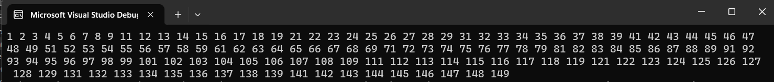

Q2) Write a C++ program to find the sum of digits of a number.  
Code  
  
Output  
  
  
  
  
  
  
  
Q3) Write a program in C++ to check whether a number is prime or not.  
Code  
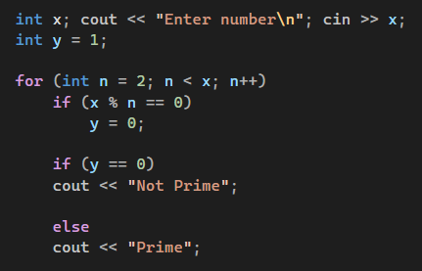  
  
Output  
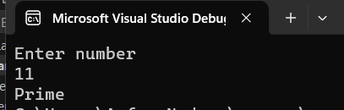S4